Example: Transaction Service
Create a global class with a method
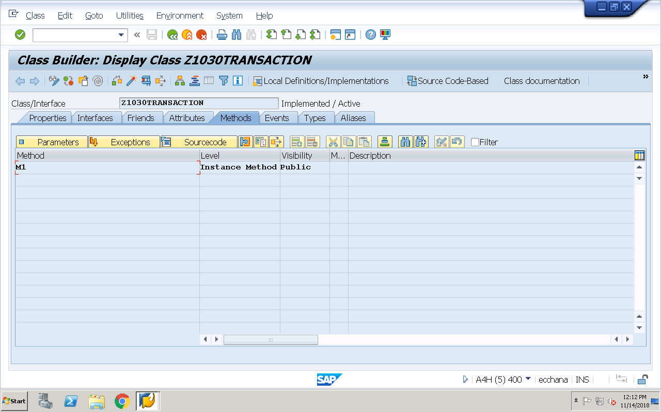
Method Implementation:
method M1.
* get the transaction manager object
data o_trans_mng type ref to if_os_transaction_manager.
CALL METHOD cl_os_system=>get_transaction_manager
RECEIVING
result = o_trans_mng.
if o_trans_mng is bound.
* create the transaction object
data o_trans type ref to if_os_transaction.
CALL METHOD o_trans_mng->create_transaction
RECEIVING
result = o_trans.
endif.
if o_trans is bound.
* start OO Transaction
TRY.
CALL METHOD o_trans->start.
* logic for creating persistent object
* get the actor class object
data o_actor type ref to zca_1030emp.
o_actor = zca_1030emp=>agent.
if o_actor is BOUND.
* create persistent object
data o_pers type ref to zcl_1030emp.
TRY.
CALL METHOD o_actor->create_persistent
EXPORTING
i_empno = 500
receiving
result = o_pers.
if o_pers is bound.
* set the values for non-key fields
o_pers->set_ename( 'Rahul' ).
o_pers->set_empdesig( 'Manager' ).
* end the OO Transaction
TRY.
CALL METHOD o_trans->end. "internally executes commit work
CATCH cx_os_check_agent_failed .
message 'Exception check agent failed' type 'I'.
CATCH cx_os_transaction .
* Cancel the transaction
CALL METHOD o_trans->undo. "internally executes rollback
ENDTRY.
endif.
CATCH cx_os_object_existing .
message 'Exception in creating persistent object' type 'I'.
ENDTRY.
endif.
CATCH cx_os_transaction .
message 'Exception in starting OO Transaction' type 'I'.
ENDTRY.
endif.
endmethod.
T-code for above method:
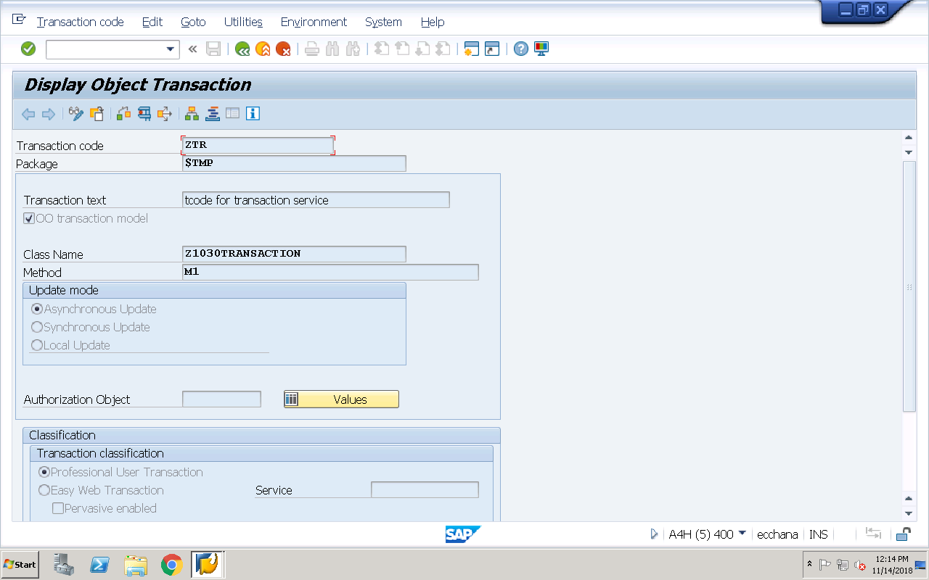
Run the T-code and check the entry in the table ‘z1030emp’

